1. How to reset to specific commit

* Run “git reflog” to see the order of commit by latest commit made

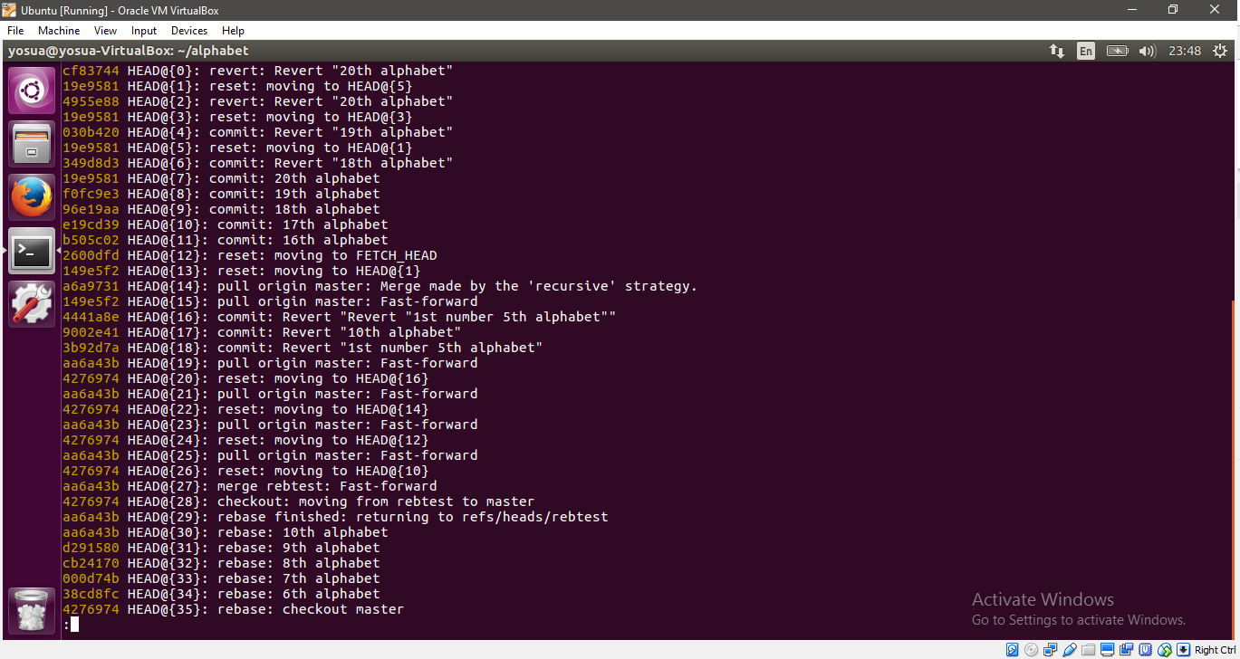

* Run “ git reset –hard HEAD@{1}
* The “1” could be replaced by next commit number or specific commit order number as you wish

1. How to force your push in effort to erase the left behind remote commit

* If you encounter a situation where your remote master left behind your local master usually after merge or rebase branch.
* Just run “git push –force”

1. How to force your pull in effort to erase the left behind remote commit

* If you encounter a situation like this

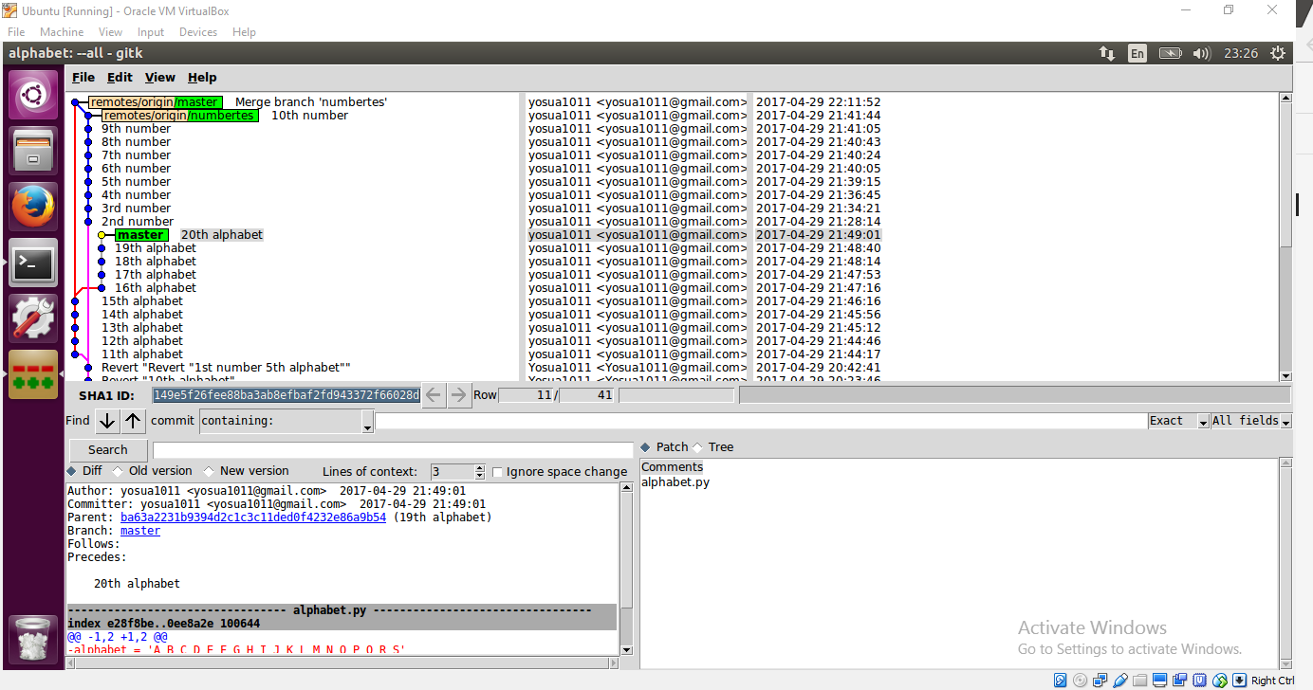

* Run “git fetch origin master”
* Run “git reset –hard FETCH_HEAD”
* Run git clean -df
* Voila

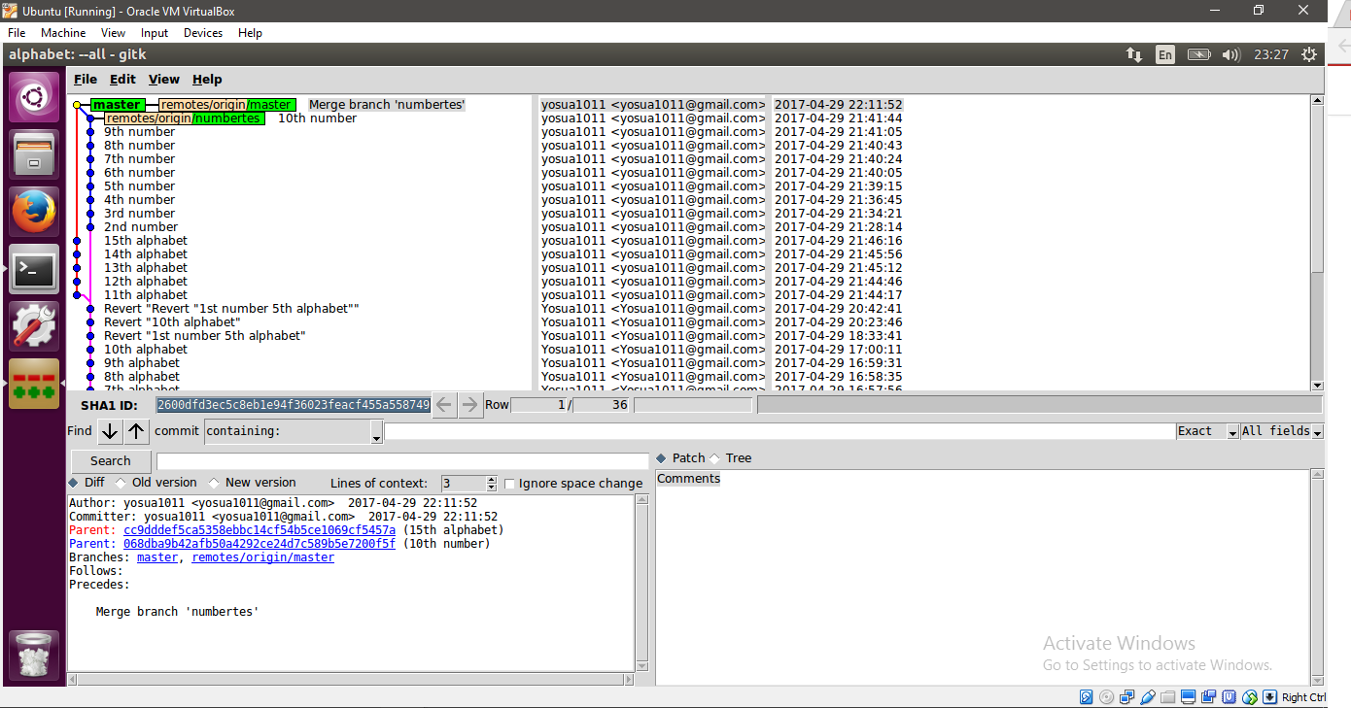

1. How to use git revert especially with specific HEAD number

To use git revert for direct back to specific commit after you push the latest local commit, you could use this command:

git revert HEAD~n

n = 0,1,2,3,4,....

Note to remember:

* n = 0 therefore your HEAD will be reset to latest commit as the parent commit, but the contains of the file is from the one commit behind your revert affect commit.

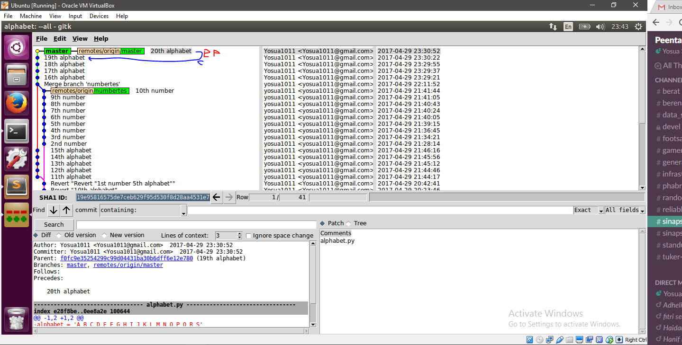

* n = 1 therefore your HEAD will be reset to one commit behind the revert affect commit as the parent commit, but the contains of the file is from the second commit behind your revert affect commit.
* n = 2 therefore your HEAD will be reset to two commit behind the revert affect commit as the parent commit, but the contains of the file is from the third commit behind your revert affect commit.

